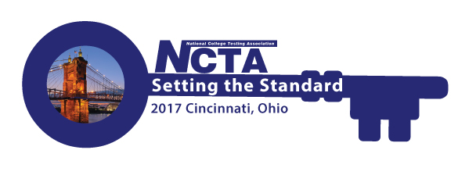
NCTA 2017 Annual Conference Committee Meeting
Monday, June 19, 2017
2:00 PM Eastern Time
GoToMeeting

Minutes

Attendance: Cindy James, Duane Goupell, Alex Martinez, Rosemary Freer, Jarret Dyer, Tabatha Phillips, Paula Doughman, Jim Wollack, Sally Frazee, Bob Lang, Jody Rosen Atkins, Jamila Maxie, Amystique Church.
Marketing. Cindy needs content for pertinent areas. Who will be sending out social media blasts? Tracy will coordinate with Jody. Should match the content that is going out in the eblasts.
Program. The program continues to evolve. Bob will highlight changes moving forward. We have three pods for the conference for which we have moderators. No need to announce the moderators for the pods. Would like to add session descriptions for the pods.
Moderators. Would be nice to use the app for moderators, possibly in August. We need to have someone oversee the moderators. Jody to order Moderator ribbons. Paula Doughman and Jan Gonzalez will oversee moderators. Jody to order First Time Attendee ribbons and Ambassador ribbons.
Sponsorships/Exhibits. There are 16 sponsors, totaling $58,500. Sponsor workshops have been scheduled.
Resource Fair. Jamila Maxie reported that invitations to SROs have been sent.
Host Committee. Paula Doughman reported that everything all set for welcome reception. Should it still be called welcome reception since it’s not until Thursday? Still need to submit orders. Have plenty of volunteers for hospitality.
Conference App. Amystique Church reported that everything is on track with the app and that training will begin soon.
Conference Planner Updates. Jody Atkins provided an update on registration and the room block. Refer to supplied reports.
Other/New Business. Tabatha reported that the ambassador program is building. They are mapping out the structure, doing a pairing survey.
Since Jody nor Duane is available July 17, Jody will send a doodle poll to determine the date for the next committee meeting.
With no further business, the meeting was adjourned at 3:00 PM.

